

|  | | Process Definition Document |
| --- | --- |

**HE CALLED MY NAME…!**

# Table of Contents

**I. Introduction 3**

I.1 Purpose of the document 3

I.2 Objectives 3

I.3 Process key contact 3

I.4 Minimum Pre-requisites for automation 4

**II.** **As-Is process description 4**

II.1 Process Overview 4

II.2. Applications used in the process 5

II.3 As-Is Process map 5

II.4 Process statistics 6

**III.** **To-Be Process Description 6**

III.1 To-Be Detailed Process Map 6

III.2 Parallel Initiatives/ Overlap (if applicable) 7

III.3 In Scope of RPA 7

III.4 Out of Scope of RPA 8

III.5 Business Exceptions Handling 8

III.6 Application Error and Exception Handling 9

**IV.** **Other Observations 10**

# Introduction

## I.1 Purpose of the document

The Process Definition Document outlines the business process chosen for automation using UiPath Robotic Process Automation (RPA) technology.

The document describes the sequence of actions performed as part of the business process, the conditions and rules of the process prior to automation and how they are envisioned to work after automating it, partly or entirely. This specifications document serves as a base for developers, providing them with the details required for applying robotic process automation to the selected business process.

## I.2 Objectives

The business objectives and benefits expected by the Business Process Owner after automation of the selected business process are:

* Deliver faster processing.
* Reduce duration of time-consuming activities.
* Leverage automation to improve the department`s overall performance and reliability.

## I.3 Process key contact

The specifications document includes concise and complete requirements of the business process and it is built based on the inputs provided by the **process** **Subject Matter Expert (SME)/ Process Owner.**

The **Process Owner** is expected **to review it and provide signoff for accuracy** and completion of the actions, context, impact and a set of process exceptions. The details are to be included in the table below.

| **Name** | **CONTACT DETAILS** | |
| --- | --- | --- |
| **E-Mail** | **Phone Number** |
| Akshaya Keerthi J | [akshayajkumar2003@gmail.com](mailto:akshayajkumar2003@gmail.com) | 9842270898 |
| Thirisha J | [thirishaj003@gmail.com](mailto:thirishaj003@gmail.com) | 9790246819 |
| Santhiya R | [santhiyaramesh16@gmail.com](mailto:sharveshpareek@gmail.com) | 7603823278 |
| Sai Esvar P | [saiesvar42206@gmail.com](mailto:saiesvar42206@gmail.com) | 9842136459 |

## I.4 Minimum Pre-requisites for automation

1. A filled in Process Definition Document.
2. Test Data to support development.
3. User access and creation of user accounts (licenses, permissions, restrictions to create accounts for robots).

# As-Is process description

## II.1 Process Overview

General information about the process selected for RPA prior to automation.

| **#** | **Item** | **Description** |
| --- | --- | --- |
| 1 | **Process full name** | He called my name…! |
| 2 | **Process Area** | Welcoming and Securing |
| 3 | **Department** | Reception and Facility |
| 4 | **Process short description (operation, activity, outcome)** | This process aims to reduce time consuming tasks in Welcoming the person and Finding the new person. |
| 5 | **Role(s) required for performing the process** | Anyone |
| 6 | **Process schedule and frequency** | Any Time |
| 7 | **# of items processed /reference period** | ~100 |
| 8 | **Process execution time** | 60.00 sec. |
| 9 | **Peak period (s)** | WeekDays |
| 10 | **Transaction Volume During Peak period** | 50 |
| 11 | **Total # of FTEs supporting this activity** | 5 |
| 12 | **Expected increase of volume in the next reference period** | 100 |
| 13 | **Level of exception rate** | 2 |
| 14 | **Input data** | Details (Excel) |
| 15 | **Output data** | E-Mail and Welcoming |

## II.2. Applications used in the process

The table includes a comprehensive list of all the applications that are used as part of the process to be automated to perform the given actions in the flow.

| **#** | **Application name & version** | **Thin/Thick Client** | **Environment/ Access method** | **Comments** |
| --- | --- | --- | --- | --- |
| 1 | Microsoft Excel | Thick | Local desktop | NA |
| 2 | Python | Thick | Local desktop | NA |

## II.3 As-Is Process map

### High Level As-Is Process Map:

This chapter depicts the As-Is business process at a High Level to enable developers to have a high-level understanding of the current process.

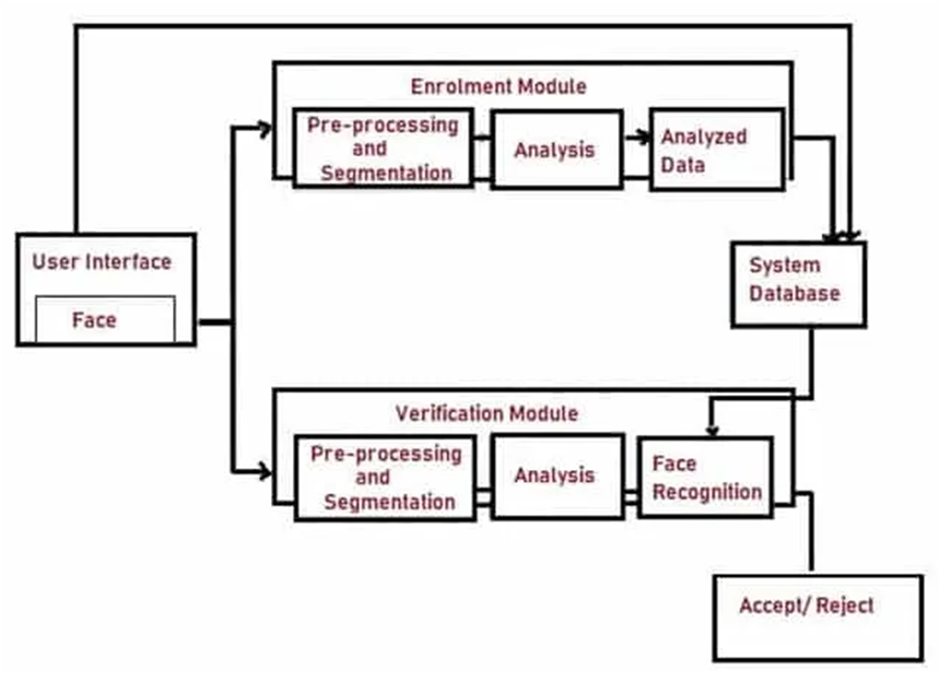

## II.4 Process statistics

### High level statistics

| **Processes** | **Windows** | **Actions** | **Mouse clicks** | **Keys pressed** | **Text entries** | **Hotkeys used** | **Time** |
| --- | --- | --- | --- | --- | --- | --- | --- |
| 1 | 2 | 20 | 2 | 3 | 2 | 4 | 60.0 sec. |

# To-Be Process Description

This chapter highlights the expected design of the business process after automation.

## III.1 To-Be Detailed Process Map



## III.2 Parallel Initiatives/ Overlap (if applicable)

This chapter covers the proposed Business, Process & System changes to be made in the near future and their impact.

| **S.No** | **Initiative Name** | **Process Action(s) where it is identified** | **Impact on current automation request? How?** | **Expected Completion Date** | **Contact person for more details** |
| --- | --- | --- | --- | --- | --- |
|  | N/A | N/A | N/A | N/A | N/A |

## III.3 In Scope of RPA

The activities **In scope of RPA**, are listed here:

1. Collecting the list of trained Person names.
2. Identifying the Person.
3. Welcoming the Person.
4. If the person is not trained, then Security mail will be sent.
5. The person can train their face (if required).

## III.4 Business Exceptions Handling

The Business Process Owner and Business Analysts are expected to document below all the business exceptions identified in the automation process. These can be classified as:

| **Known** | **Unknown** |
| --- | --- |
| Previously encountered. A scenario is defined with clear actions and workarounds for each case. | New situation never encountered before. It can be caused by external factors. Cannot be predicted with precision, however if it occurs, it must be communicated to an authorized person for evaluation. |

### Known Exceptions

The table below reflects all the business process exceptions encountered during the process evaluation and documentation. These are **known exceptions** that occurred before. For each of these exceptions, define a corresponding expected action that the robot should complete if it encounters the exception.

| **BE #** | **Exception name** | **Step where error occured** | **Parameters** | **Action to be taken** |
| --- | --- | --- | --- | --- |
| 1. | DataUnavailable | Extracting Data from excel | No data found | Warn the user to populate valid data. |
| 2. | InvalidData | Extracting Data from excel | Data does not match expected format | Warn the user to enter valid data in the excel. |

### Unknown Exceptions

For all other unanticipated or unknown business (process) exceptions, the robot should send an email notification at **exceptions@xyz.com** with the original email and error message screenshot attached.

# Other Observations

Include below any other relevant observations you consider needed to be documented here.

**N/A**